Paper Title
Author 1ª, Author 2^{b}, AUTHOR 3^{c},…
ª Laboratory, Affiliation, City, Country, E-mail address
^{b} Laboratory, Affiliation, City, Country, E-mail address
^{c} Laboratory, Affiliation, City, Country, E-mail address
Abstract – The paper should start with an abstract of 150−200 words, which summarises the objectives, and conclusions of the paper. The abstract should not include references, figures or tables. The abstract is very important as it will be published on the proceeding of the International Vibration Conference CVI2017;
Key words: Not exceed five key words written in lower-case letters separated by slashes: Max 5 words..
.

- Introduction
The paper must be written in English. All communications are subject to peer review. Only those papers that have received a favourable opinion of the reviewers will be accepted for presentation at the conference CVI2017.
Authors are asked to submit their manuscript (PDF format) online conference Web site:
http://cvi2017.sciencesconf.org
The number of pages of the proposed communication shall be between 2 and 6 pages excluding the title page.
- Paper presentation
The manuscript must be written in simple line, double column, in Times New Roman font, size 10, with margins of 2.5 cm, must include, in order: a summary page, the text (including figures and tables), references and eventually annexes. All pages must be numbered.
Summary page
The summary page should contain the title of the manuscript, which must be concise while explicit, the first name (printed), and each person's name, full contact details (address, e-mail…).
As a result, it must include a summary in English (maximum 200 words for each abstract). It will also include a maximum of five keywords in English (written in lower separated by slashes).
Title of chapters
The chapter headings are numbered as follows: 1 ; 1.1 ; 1.1.1 ; … in boldface Time New Roman.
Figures and Tables
The figures and tables will be numbered in Arabic numerals growing as they appear in the text. The figures, with their legends and tables, with their titles should be incorporated into the text.

Figures
All illustrations (drawings or photographs) should be called in the text. Figure 1 we shall write in letters in the text

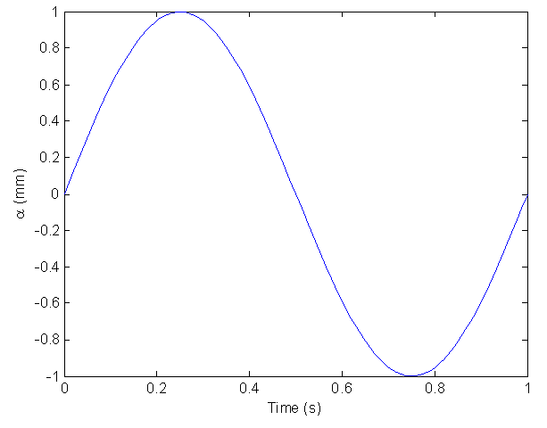
Figure 1. Style figure

Tables
Table 1. Style table
Table Head | Table Column Head
 | Table column subhead | Subhead
Copy | More table copy
- Equations
The equations must be carefully written. Those referenced in the text [in the form: Equation (1), for example] shall be numbered consecutively in Arabic numerals in parentheses beside the right margin:
                                                            
Do not put punctuation at the end of the equations. Particular attention should be paid to clearly differentiate the number zero (0) and the letter O, the number one (1) and the letter l, the letter v Roman and Greek letter nu (υ).
- References
The template will number citations consecutively within brackets. Refer simply to the reference number, as in [3]—do not use “Ref. [3]” or “reference [3]” except at the beginning of a sentence: “Reference [3] was the first . . .” Unless there are six authors or more give all authors' names; do not use “et al.”. The style and punctuation of references must conform to the models illustrated in the following examples:

[1] J.-C. Batsale, D. Maillet, A. Degiovanni, Extension de la méthode des quadripôles thermiques à l’aide de transformations intégrales, Int. J. Heat Mass Trans. 1 (1994) 111–127
[2] M.N. Ozisik, Radiative transfer and interactions with conduction and convection, JohnWiley and Sons, New York, 1973
[3] D. Bougeard, J.-P. Vermeulen, B. Baudoin, Spatial resolution enhancement of an IR system by image restoration techniques, Proceedings of Quantitative Infrared Thermography QIRT 94 (Eurotherm Seminar 42), Elsevier, Paris, France, 1995, pp. 3–6.

